
Touchstones
Netcards

Care of the Soul Netcards with Text

Art HRJ
Bird HRJ
Black Lives Matter HRJ
Bread HRJ

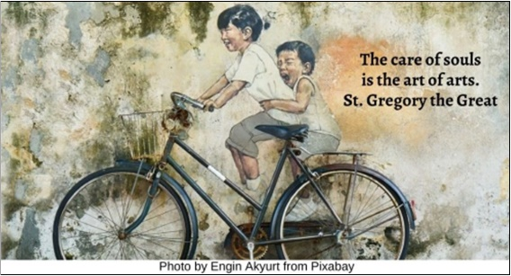

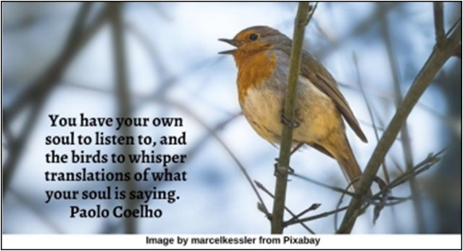

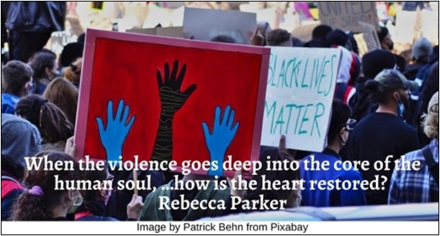

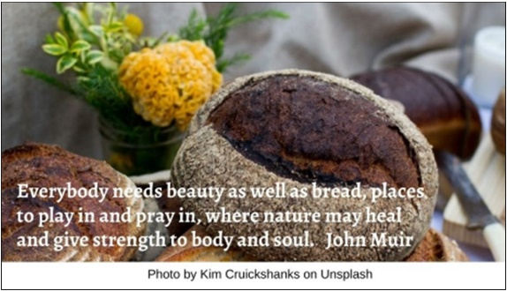

Breath HRJ
Circle of Care HRJ
Creation HRJ
Door HRJ

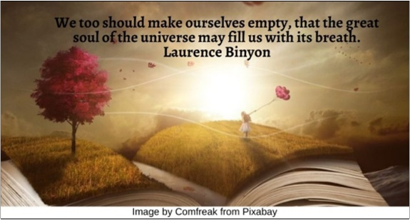



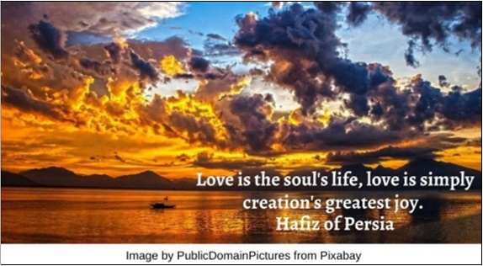

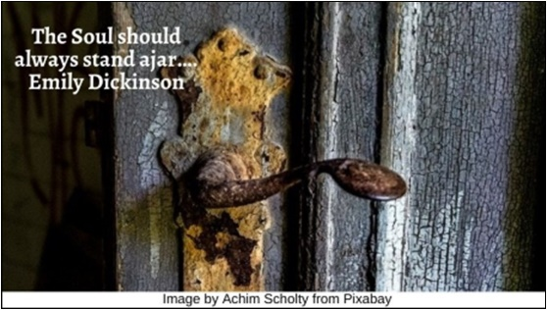

Grow HRJ
Heart HRJ
Honor HRJ
Hospitality HRJ

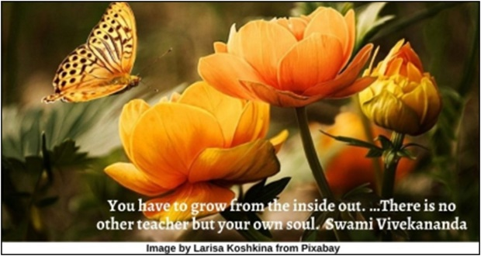

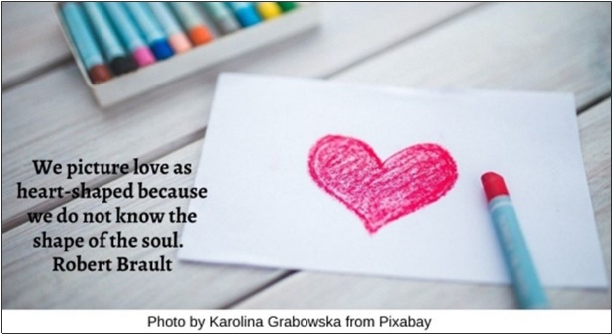

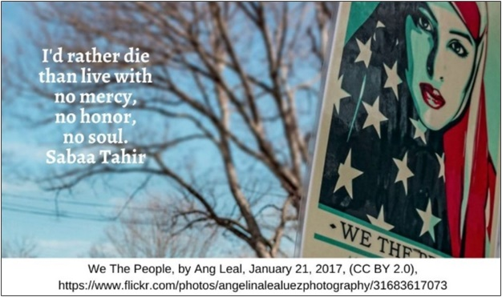

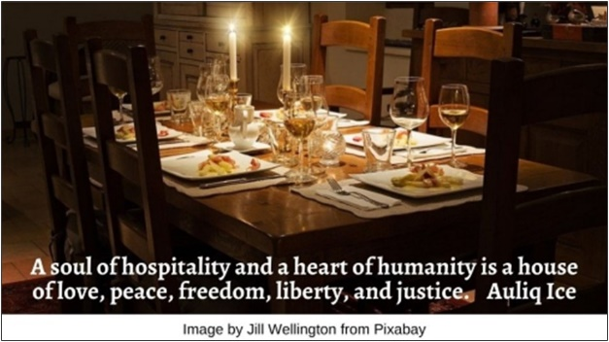

Joy HRJ
Lamp HRJ
Listen HRJ
Map HRJ

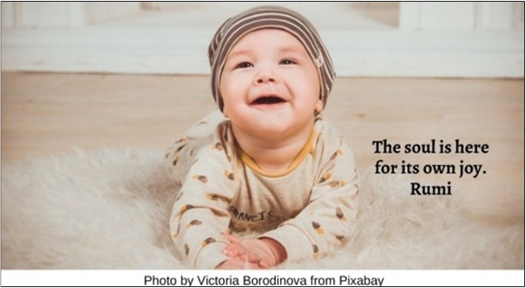

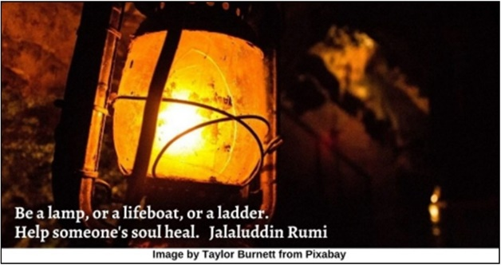

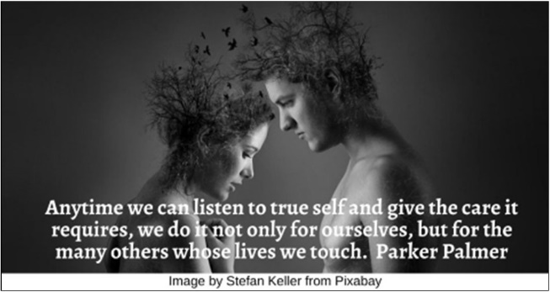

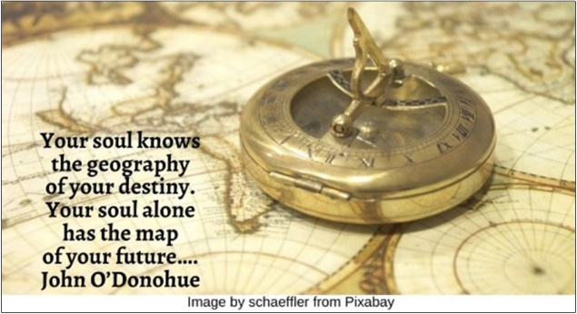

Meditation HRJ
Ordinary HRJ
Owl HRJ
Painting HRJ

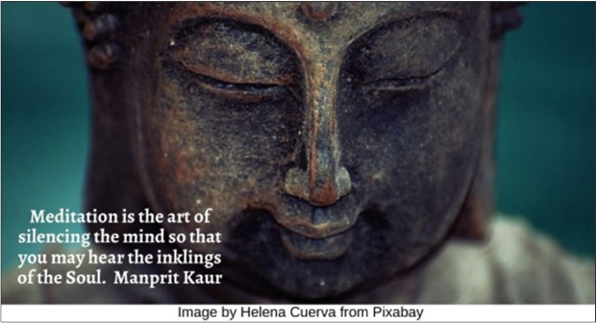

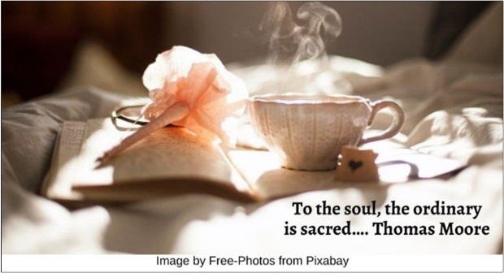

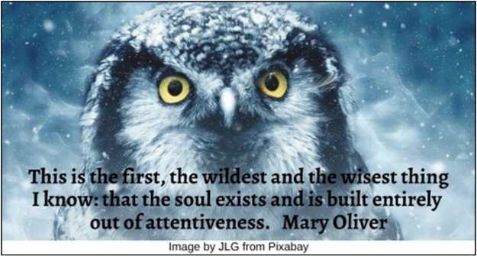

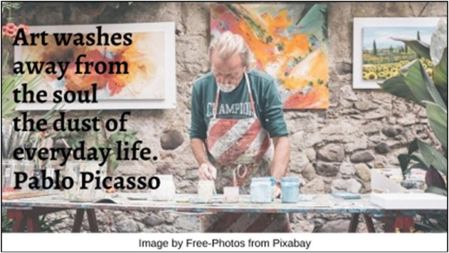

Quality of Life HRJ
Rain of Relationship HRJ
Renewal of the Mind HRJ
Solitude HRJ

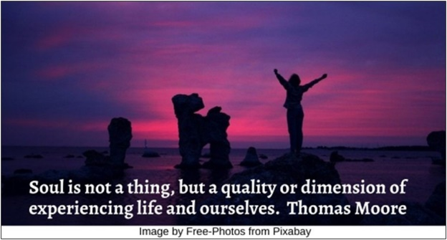

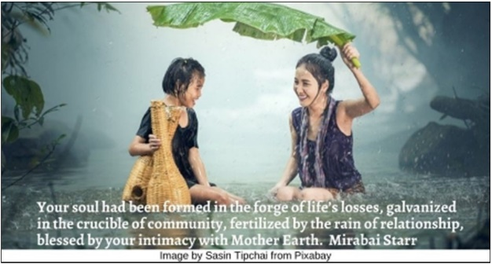

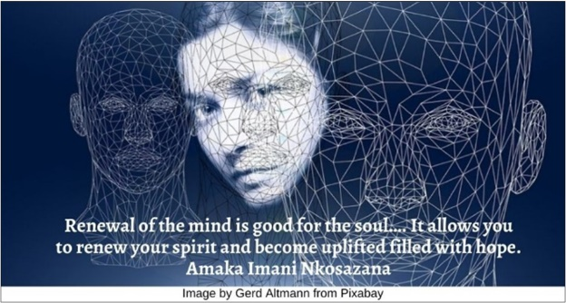

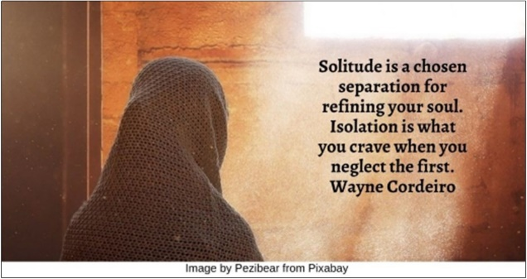

Stillness HRJ
Tire HRJ
Tomorrow HRJ
The Soul HRJ

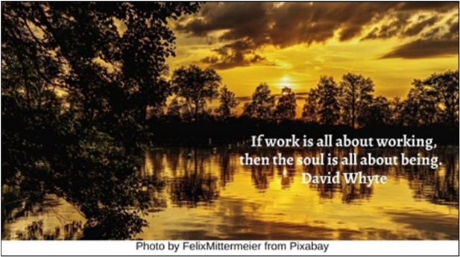

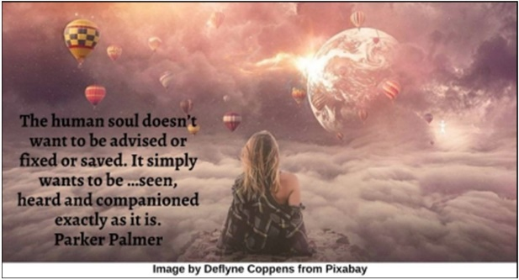



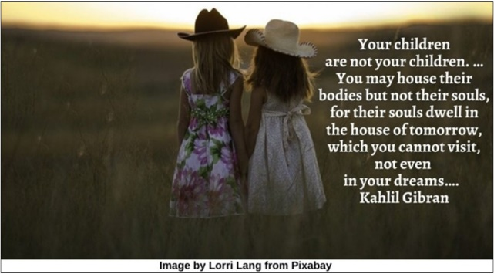

Travel HRJ
Wilderness HRJ
Woman and Child HRJ

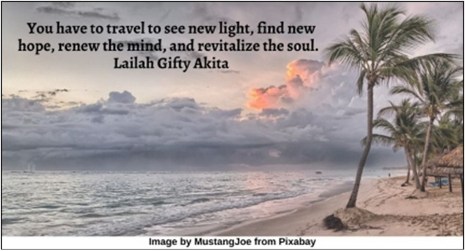

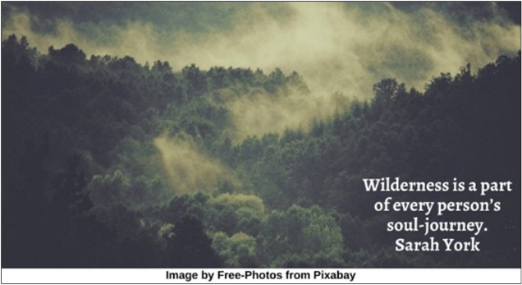

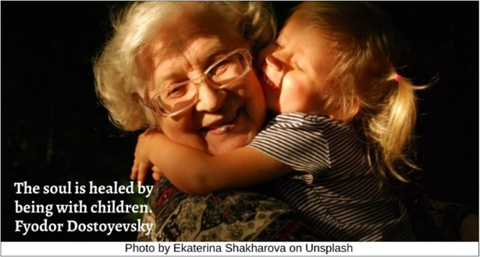

Text of Quotes
Art HRJ
The care of souls is the art of arts. St. Gregory the Great

Bird HRJ
You have your own soul to listen to, and the birds to whisper translations of what your soul is saying. Paolo Coelho

Black Lives Matter HRJ
When the violence goes deep into the core of the human soul, …how is the heart restored? Rebecca Parker

Bread HRJ
Everybody needs beauty as well as bread, places to play in and pray in, where nature may heal and give strength to body and soul. John Muir

Breath HRJ
We too should make ourselves empty, that the great soul of the universe may fill us with its breath. Laurence Binyon

Circle of Care HRJ
To care for those who once cared for us is one of the highest honors. Tia Walker

Creation HRJ
Love is the soul's life, love is simply creation's greatest joy. Hafiz of Persia

Door HRJ
The Soul should always stand ajar…. Emily Dickinson

Grow HRJ
You have to grow from the inside out. …There is no other teacher but your own soul. Swami Vivekananda

Heart HRJ
We picture love as heart-shaped because we do not know the shape of the soul. Robert Brault

Honor HRJ
I'd rather die than live with no mercy, no honor, no soul. Sabaa Tahir

Hospitality HRJ
A soul of hospitality and a heart of humanity is a house of love, peace, freedom, liberty and justice. Auliq Ice

Joy HRJ
The soul is here for its own joy. Rumi

Lamp HRJ
Be a lamp, or a lifeboat, or a ladder. Help someone's soul heal. Jalaluddin Rumi

Listen HRJ
Anytime we can listen to true self and give the care it requires, we do it not only for ourselves, but for the many others whose lives we touch. Parker Palmer

Map HRJ
Your soul knows the geography of your destiny. Your soul alone has the map of your future…. John O’Donohue

Meditation HRJ
Meditation is the art of silencing the mind so that you may hear the inklings of the Soul. Manprit Kaur

Ordinary HRJ
To the soul, the ordinary is sacred…. Thomas Moore

Owl HRJ
This is the first, the wildest and the wisest thing I know: that the soul exists and is built entirely out of attentiveness. Mary Oliver

Painting HRJ
Art washes away from the soul the dust of everyday life. Pablo Picasso

Quality of Life HRJ
Soul is not a thing, but a quality or dimension of experiencing life and ourselves. Thomas Moore

Rain of Relationship HRJ
Your soul had been formed in the forge of life’s losses, galvanized in the crucible of community, fertilized by the rain of relationship, blessed by your intimacy with Mother Earth. Mirabai Starr

Renewal of the Mind HRJ
Renewal of the mind is good for the soul…. It allows you to renew your spirit and become uplifted filled with hope. Amaka Imani Nkosazana

Solitude HRJ
Solitude is a chosen separation for refining your soul. Isolation is what you crave when you neglect the first. Wayne Cordeiro

Stillness HRJ
If work is all about working, then the soul is all about being. David Whyte

Tire HRJ
Listening to those who want to be heard is where the rubber of the soul meets the road of real life. Ari Weinzweig

Tomorrow HRJ
Your children are not your children. …You may house their bodies but not their souls, for their souls dwell in the house of tomorrow, which you cannot visit, not even in your dreams…. Kahlil Gibran

The Soul HRJ
The human soul doesn’t want to be advised or fixed or saved. It simply wants to be …seen, heard and companioned exactly as it is. Parker Palmer

Travel HRJ
You have to travel to see new light, find new hope, renew the mind and revitalize the soul. Lailah Gifty Akita

Wilderness HRJ
Wilderness is a part of every person’s soul-journey Sarah York

Woman and child HRJ
The soul is healed by being with children. Fyodor Dostoyevsky

